**PO 336 - Identify Meteorological Conditions**

**Composition of the atmosphere**  **Layers of the atmosphere**

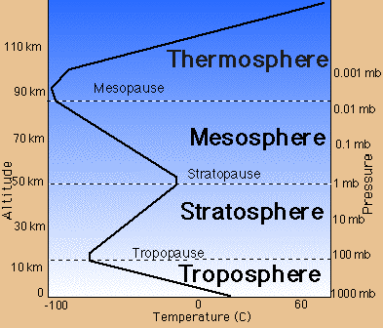

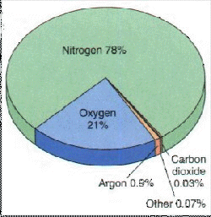

Note that the ozone layer is part of the stratosphere

**The ICAO assumptions for Standard Atmosphere in North America:**

1. Air is a perfectly dry gas

2. Mean sea level pressure of 29.92 inches of mercury (''Hg)

3. Mean sea level temperature of 15oC

4. Temperature decreases with altitude at a rate of 1.98oC per 1000 feet

**Properties of the Atmosphere:**

1. **Mobility** - the ability of air to move from one place to another

2. **Capacity for Expansion** - Air is forced to rise for various reasons. As the pressure decreases, the air expands and cools. The cooling may be enough for condensation to occur and clouds to form.

3. **Capacity for Compression** - Compression occurs when the air has cooled and becomes denser. The air then sinks, decreasing in volume and increasing in temperature.

**Factors affecting the properties of the atmosphere:**

1. Temperature

2. Density

3. Pressure

**Cloud Classifications**

*Main classifications*

1. Stratus - flat layers, blanket like

2. Cumulus - Puffy

*Cloud Height*

1. Low

2. Middle

3. High

4. Clouds of vertical development- see diagram

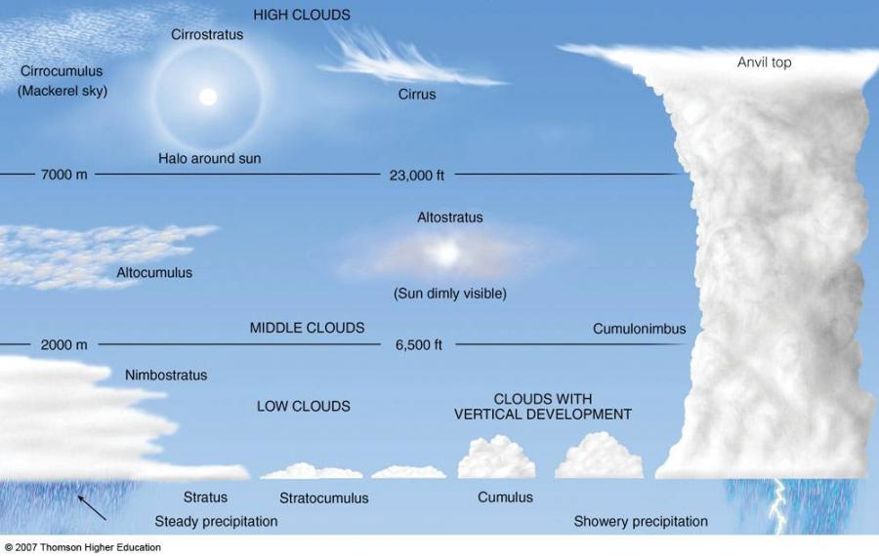

**Stable Air**

If a mass of rising air is cooler than the air that it comes in contact with, then it will sink back to it's original position. Affects on flight characteristics:

- poor low-level visibility (fog)

- stratus type cloud

- steady precipitation

- steady winds

- smooth flying conditions

**Unstable Air**

If a mass of rising air is still warmer than the air around it, then the air mass will continue to rise. Affects on flight characteristics:

- good visibility (except in precipitation)

- cumulus type cloud

- showery precipitation

- gusty winds

- moderate to severe turbulence

**Lifting Agents -** provide lift to initiate rising currents of air

* *Convection -* Air is heated through contact with the earth's surface. As the sun heats the surface, the air in contact with the surface heats, rises, and expands. Convection may also occur when air moves over a warmer surface and is heated by advection.
* *Orthographic Lift* - Occurs when sloping terrain forces air upward
* *Frontal Lift -* When different air masses meet, warmer air is forced upward by denser, colder air
* *Mechanical Turbulence -* Air moving over terrain that is not as pronounced as mountains (buildings, forests, quarries, etc) through friction.
* *Convergence -* In a low pressure system, the wind blows toward the center of the system. The excess air that collects here is forced upward to higher altitudes.

**Pressure Systems**

*Isobars -* areas of pressure joined by lines (circle-like items on weather map)

*Low Pressure Areas* - Areas of relatively low pressure with the lowest point at the center. These normally move in an easterly direction and are associated with thunderstorm s and tornadoes.

*High Pressure Areas-* Areas of relatively high pressure with the highest point at the center. Winds are light and variable and these systems generally more slower than low pressure systems.

**Wind** - the horizontal movement of air within the atmosphere. Wind generally moves parallel to isobars.

**Humidity -** a representation of the moisture or water vapour, which is present in the air mass.

*Condensation -* the process by which gas turns into a liquid by becoming denser.

*Sublimation -* the process by which gas changes to solid without becoming a liquid first.

*Dew Point - the temperature to which unsaturated air must be cooled, at a constant pressure, in order to become saturated*

**PO 331 - Describe Principles of Flight**

**Characteristics of Stability**

*Aircraft stability* - The tendency of an aircraft in flight to remain in straight, level, upright flight and to return to this attitude, if displaced, without corrective action by the pilot.

*Static stability -* The initial tendency of an aircraft to return to its original attitude, if displaced.

*Dynamic stability - The overall tendency of an aircraft to return to its original attitude*

*Longitudinal stability* - stability around the lateral axis which influenced by the plane's center of gravity and the horizontal stabilizer.

*Directional stability* - stability around the vertical axis which is also called roll stability